Tatu Bogdan – CTI EN 3.1

EDGE-TRIGGERED D FLIP-FLOP

* Clock: f = 20 MHz
* Input Voltage: T1 = 2ns T = 7ns

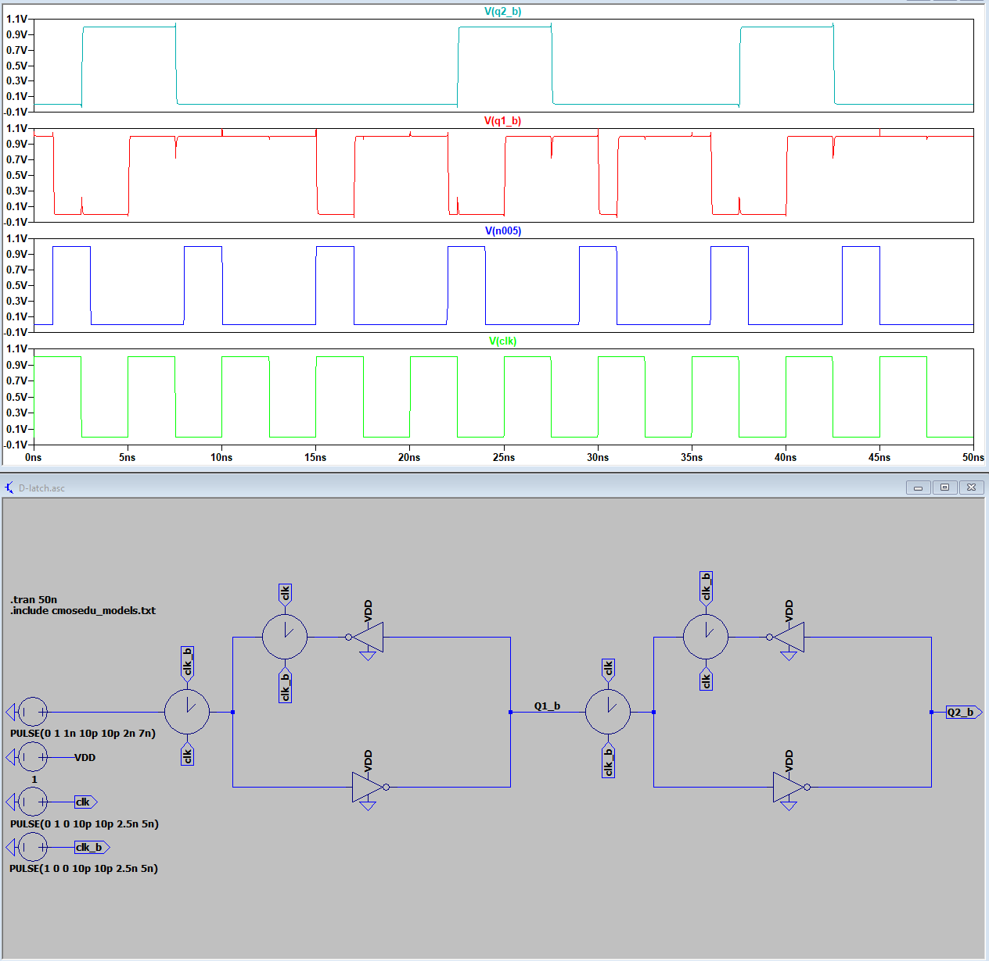

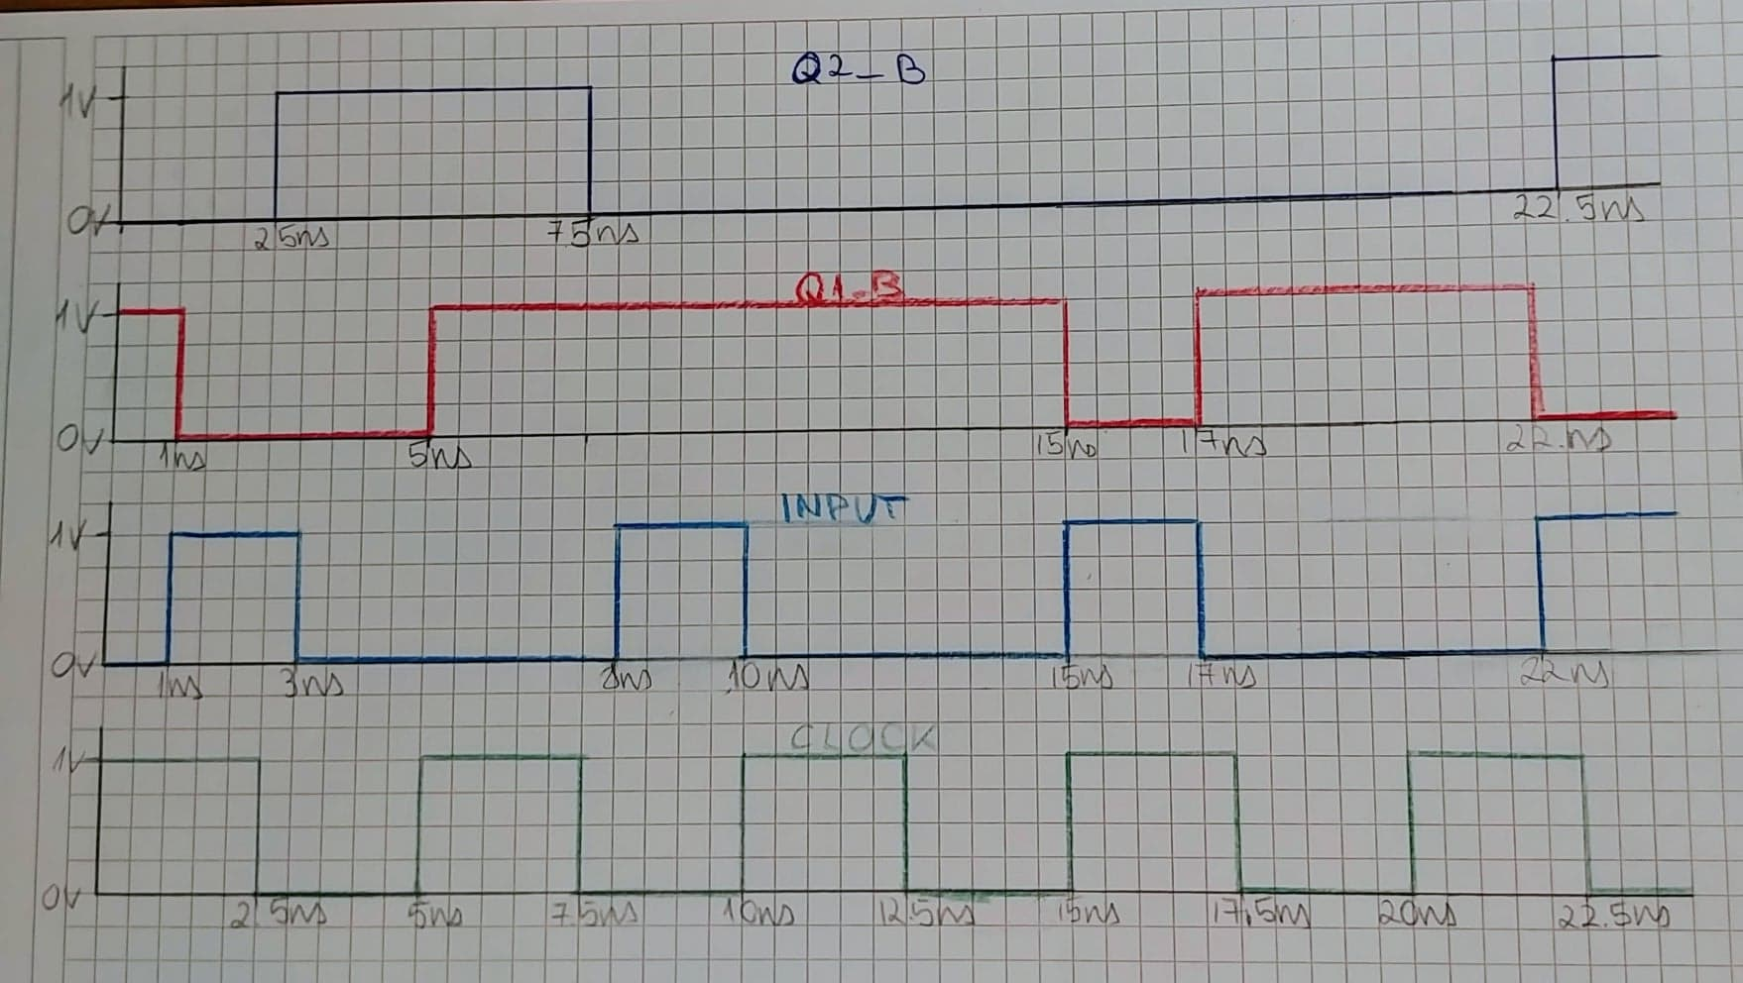

* 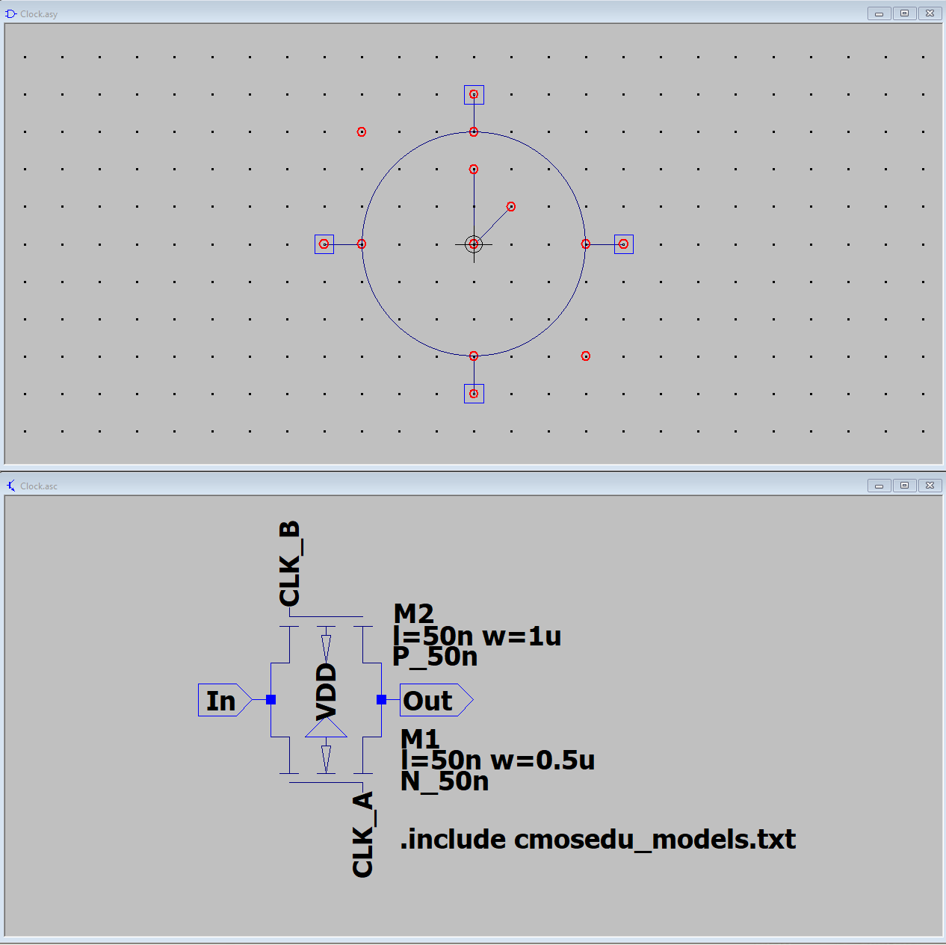Clock Component